**Steps to Reproduce the EEG Acquisition Pipeline**

1. Install DipTrace (schematic and PCB design software).

2. Open the document “Layout” with DipTrace.

3. Print the PCB layout by generating and sending the gerber files to a specialized company that manufactures printed circuit boards.

4. Buy all the components listed in the document “Components”.

5. Solder every component on the printed board with the help of the “Schematic” document. In this document, the value of every component is assigned to the component’s code (i.e. R34 or C11) referring to the footprints on the “Layout”.

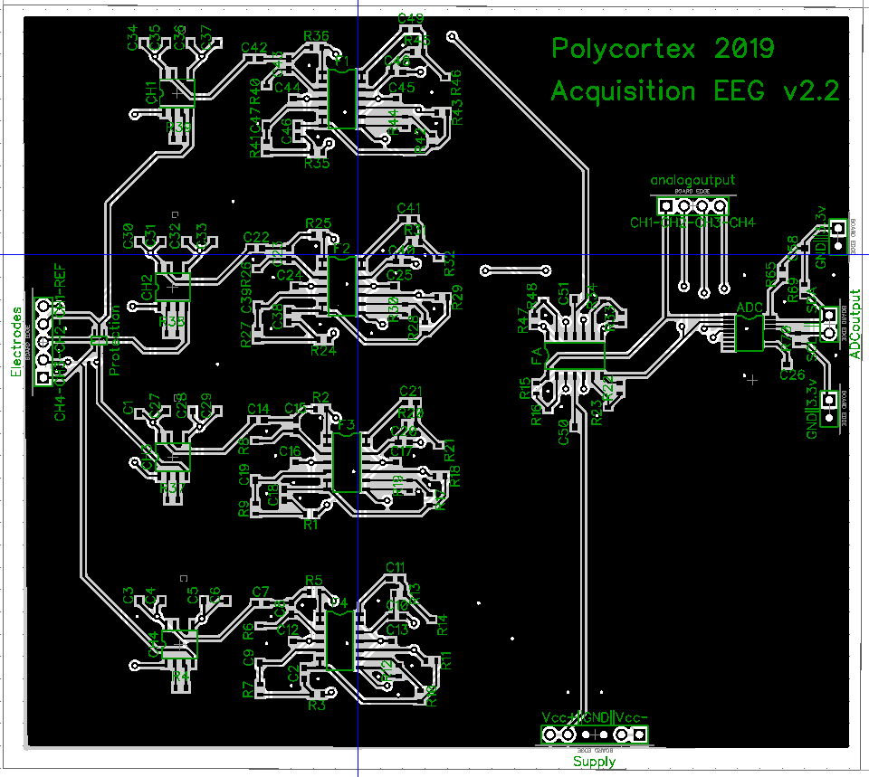

Reference

Channel 1

Channel 2

Channel 3

Channel 4

E4

E3

E2

E1

SDA

SCL

Vcc+ (9V)

Vcc+ (9V)

GND

GND

Vcc- (-9V)

Vcc- (-9V)

6. Install the visualization interface on a computer. Import all required libraries

7. Test the circuit by connecting a sinusoidal signal with a waveform generator at the minimal tension (i.e. 20 mV) and at a frequency of 20 Hz. Connect the positive terminal of the waveform generator to the channel 1 (on the “Electrodes” header) and the negative Reference terminal to the reference electrode (on the “Electrodes header). Connect with femalefemale wires the GND and the Vcc+ and Vcc- (on the “Supply” header) to 9V batteries. The ADC is powered by the 3.3V output of the Arduino, which is connected to a computer. Connect the GND and 3.3v pins to the corresponding pins of the Arduino. Connect the negative terminal of an oscilloscope to the GND and the positive terminal to the “CH-1” output (on the “analogoutput” header). A square signal at 20 Hz should appear. Because the lowest amplitude generated by the instrument is much higher than an EEG signal (20 mV >> 100 µV), the output signal will saturated, therefore displaying a the square form. It is possible to use a tension divider to inject the circuit with a smaller signal (i.e. 20 µV).

8. Visualize the temporal and spectral signal on the interface by connecting the SDA and SCL pins (on the “ADCoutput” header) to the corresponding pins on the Arduino with female-female wires. Open “app.py”, available in the “code” folder, with an IDE such as Spyder 3. Run the program. An interface will appear on the screen with the temporal and frequential signals. The square signal should appear on the top left corner diagram (Electrode 1) et a spike indicating the dominant frequency should appear around 20 Hz on the corresponding frequency diagram (FFT).

9. Redo steps 7 and 8 with all the channels to insure each one is welded properly.

10. Visualize the EEG by connecting electrodes to the respective pins on the “Electrodes” header according to needs. Connect the reference electrode to the reference pin of the same header. Display the 4 signals on the screen of the computer.